
Announcement from Mueang Phrae Provincial Police Station
Subject: Honest intentions in the management of Muang Phrae Police Station
.......................................................
Mueang Phrae Provincial Police Station, Phrae Province, would like to announce its intention to manage its work with honesty and integrity according to the principles of good governance, transparency and auditability. Ready to take responsibility to build confidence in society that Mueang Phrae Police Station, Phrae Province
Intent to oppose all forms of corruption and intended to Mueang Phrae Provincial Police Station, Phrae Province, is an organization with good governance and transparency. To be consistent with the values ​​of the Royal Thai Police, which is defined as "honest, fair", will be carried out as follows.
1. Perform duties in every step in accordance with the laws, rules, and regulations completely and strictly, as well as encourage personnel to perform their duties according to the laws, rules, and regulations specified.
2. Cultivate and create awareness Values ​​in fighting corruption Know how to distinguish personal and public benefits. To instill a sense of morality and prevent corruption in the agency. including strong internal checks and balances effective This will make personnel in Muang Phrae Police Station, Phrae Province aware of the harmful effects and dangers of corruption on Mueang Phrae Police Station, Phrae Province, and the nation. To create a sustainable anti-corruption culture.
3. Do not accept corruption behavior. and does not tolerate corruption
4. Committed to performing duties with transparency, equality, fairness, honesty, speed, and efficiency, keeping up with the dynamics of corruption and consistent with standards in performing duties.
5. Focus on managing work based on the principles of good governance and jointly creating a culture in the organization and will manage the budget with transparency and value. Bring the greatest benefit to the government and are ready to show responsibility if the performance of duties of the Mueang Phrae Police Station, Phrae Province, has an impact and causes damage to society as a whole.
Therefore, it is announced for everyone to know
Announced on 2 January 2025.
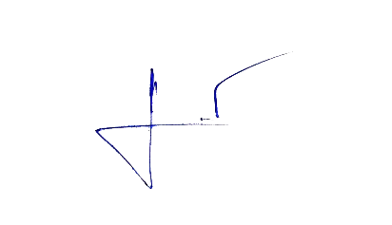
Checked and correct

Police Colonel
(Surachai Chantaramanee)
Superintendent of Long Provincial Police Station
Acting Superintendent of Mueang Phrae Police Station

